Summa E-rate Solutions
FY2023 E-Rate Request for Proposals

REQUEST FOR PROPOSALS
E-Rate Eligible Category 2 Products and Services
ADDENDUM 1
Form 470 # 230013369 (120B-22) – E-rate Funding Year 2023

Name of RFP: High Speed Data Internal Connections –
No Install

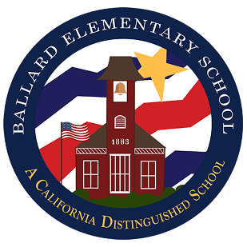
Question:

We missed the first walkthrough that was scheduled for January 11th.
Can we still attend the second walkthrough that is scheduled for Thursday January 19th?
Or, if we missed one walkthrough does that disqualify us from bidding?

Answer:

Thank you for the question. FCC Form 470 #230010903 RFP 119B-23 was cancelled and was replaced by FCC Form 470 #230013369 RFP 120B-23 certified on 1/12/23 and due 2/13/23. The walk-through times are scheduled on January 11th and 19th at 9:00 a.m. See below. However, the walk-throughs are not mandatory, so you are not disqualified for not attending either walk-through but are scheduled for the purpose of better helping the bidder understand the scope of work. You are invited to attend the remaining walk-through scheduled on Jan 19th at 9:00 a.m.

Walk through
There will be a walk-through of the school sites on Wednesday, January 11, 2023, and Thursday, January 19, 2023. The walk-through will start promptly at 9:00 a.m. Please meet at the Ballard Elementary School District East School Office, at 2425 School St., Solvang, CA 93463.

